Experiment No – 2
Title / Aim :- Use var, let, const, and demonstrate basic features like template literals and destructuring; build a billing calculator with user input.

Software/Tools Required :-
- Visual Studio Code (VS Code)
- Google Chrome / Any Web Browser
- HTML
- JavaScript

CODE :-
<!DOCTYPE html>
<html lang="en">
<head>
<meta charset="UTF-8">
<meta name="viewport" content="width=device-width, initial-scale=1.0">
<title>TechZone Computer Store</title>

<style>

*{
margin:0;
padding:0;
box-sizing:border-box;
font-family:'Segoe UI',sans-serif;
}

body{

min-height:100vh;

display:flex;
justify-content:center;
align-items:center;

background:
linear-gradient(rgba(0,0,0,.15),rgba(0,0,0,.15)),
url("https://encrypted-tbn0.gstatic.com/images?q=tbn:ANd9GcSjkHFxkp-v2_11nBsAKTZihC1yr9yPB1q_zngMHVYPVw&s=10");

background-size:cover;
background-position:center;

}

/* Animated Grid */

body::before{

content:"";

position:absolute;

width:100%;
height:100%;

background-image:

linear-gradient(rgba(255,255,255,.04) 1px,transparent 1px),

linear-gradient(90deg,rgba(255,255,255,.04) 1px,transparent 1px);

background-size:35px 35px;

}

/* RGB Border */

.card{

width:500px;

background:#111827;

border-radius:20px;

padding:4px;

background:linear-gradient(
45deg,
#00e5ff,
#2979ff,
#00c853,
#ffea00,
#ff1744,
#00e5ff);

background-size:500%;

animation:rgb 8s linear infinite;

position:relative;

}

@keyframes rgb{

0%{background-position:0%}

100%{background-position:500%}

}

.inner{

background:#111827;

border-radius:18px;

overflow:hidden;

color:white;

}

/* Header */

.header{

padding:25px;

text-align:center;

background:#1f2937;

border-bottom:2px solid #00e5ff;

}

.logo{

font-size:55px;

}

.header h1{

margin-top:10px;

color:#00e5ff;

}

.header p{

color:#cbd5e1;

margin-top:8px;

}

/* Chip */

.chip{

display:inline-block;

margin-top:15px;

padding:8px 18px;

background:#00e5ff;

color:#111827;

border-radius:20px;

font-weight:bold;

}

/* Content */

.content{

padding:28px;

}

.row{

display:flex;

justify-content:space-between;

padding:15px 0;

border-bottom:1px solid #374151;

}

.label{

color:#00e5ff;

font-weight:bold;

}

.summary{

margin-top:20px;

}

.box{

display:flex;

justify-content:space-between;

padding:14px;

margin:10px 0;

background:#1f2937;

border-left:5px solid #00e5ff;

border-radius:8px;

}

/* Total */

.total{

margin-top:18px;

display:flex;

justify-content:space-between;

background:#00e5ff;

color:#111827;

padding:18px;

font-size:24px;

font-weight:bold;

border-radius:10px;

box-shadow:0 0 20px #00e5ff;

}

.footer{

text-align:center;

padding:20px;

color:#94a3b8;

}

.footer strong{

color:#00e5ff;

}

.inner:hover{

transform:translateY(-5px);

transition:.4s;

}

</style>

</head>

<body>

<div class="card">

<div class="inner">

<div class="header">

<div class="logo">

💻

</div>

<h1>TECHZONE</h1>

<p>Computer & Gaming Store</p>

<div class="chip">

✔ WARRANTY INCLUDED

</div>

</div>

<div id="receipt"></div>

<div class="footer">

<strong>Thank You!</strong>

<br>

</div>

</div>

</div>

<script>

// var

var customerName=prompt("Enter Customer Name");

// let

let productName=prompt("Enter Product Name");

let price=Number(prompt("Enter Product Price"));

let quantity=Number(prompt("Enter Quantity"));

// const

const GST_RATE=0.18;

// Calculation

let subtotal=price*quantity;

let gst=subtotal*GST_RATE;

let total=subtotal+gst;

// Object

const bill={

customerName,
productName,
price,
quantity,
subtotal,
gst,
total

};

// Destructuring

const{

customerName:cname,

productName:pname,

price:pprice,

quantity:qty,

subtotal:sub,

gst:gstAmount,

total:grandTotal

}=bill;

// Template Literals

document.getElementById("receipt").innerHTML=`

<div class="content">

<div class="row">

<span class="label">👤 Customer</span>

<span>${cname}</span>

</div>

<div class="row">

<span class="label">💻 Product</span>

<span>${pname}</span>

</div>

<div class="row">

<span class="label">💰 Price</span>

<span>₹${pprice.toFixed(2)}</span>

</div>

<div class="row">

<span class="label">📦 Quantity</span>

<span>${qty}</span>

</div>

<div class="summary">

<div class="box">

<span>Subtotal</span>

<span>₹${sub.toFixed(2)}</span>

</div>

<div class="box">

<span>GST (18%)</span>

<span>₹${gstAmount.toFixed(2)}</span>

</div>

<div class="total">

<span>Total</span>

<span>₹${grandTotal.toFixed(2)}</span>

</div>

</div>

</div>

`;

</script>

</body>
</html>

OUTPUT:-

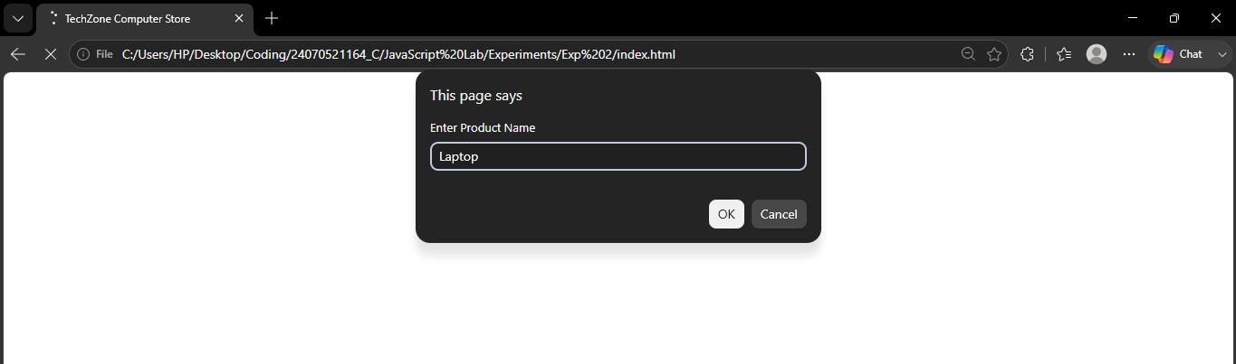

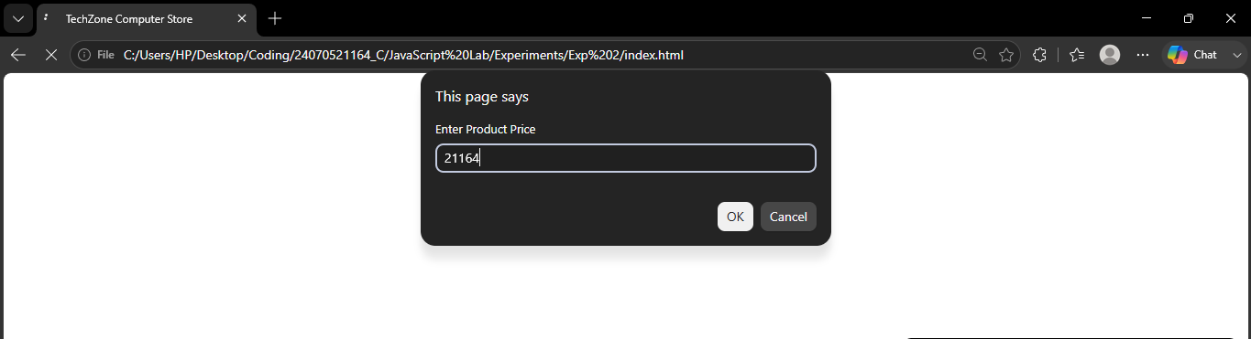
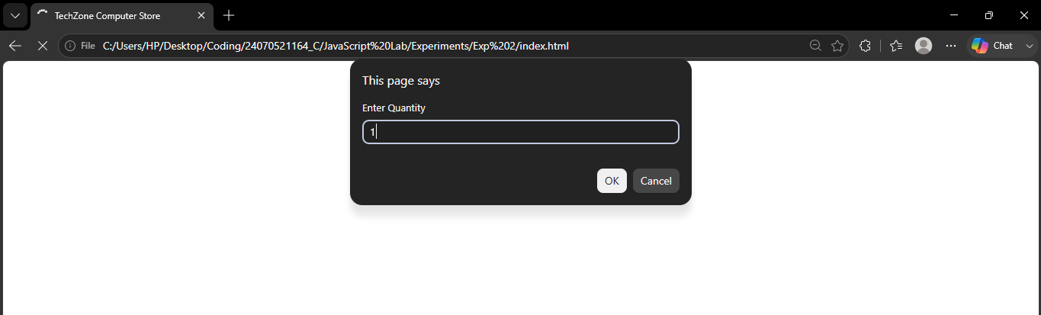

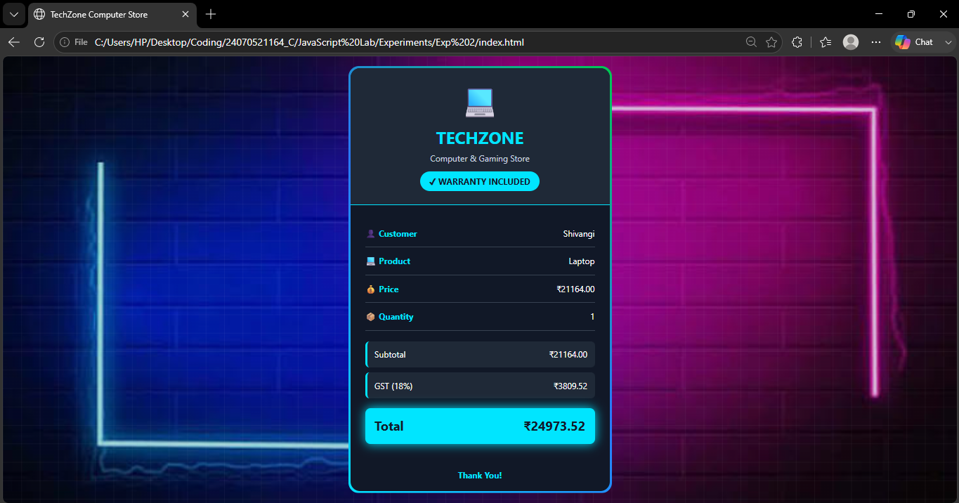

Result / Conclusion :- The Billing Calculator was successfully developed using HTML, CSS, and JavaScript. The program correctly accepts user input, calculates the subtotal, GST (18%), and total amount, and displays a well-formatted billing receipt. This experiment enhanced the understanding of JavaScript concepts such as variable declarations, template literals, object destructuring, user input handling, and DOM manipulation while creating an interactive web application.

